Lesson 9
Assembler Directives

Overview
Introduction |  | In this lesson, we will examine a number of assembler directives that we will not cover elsewhere in the course.
In this section |  | Following is a list of topics in this section:
 | Description |  | See Page
 | Number Formats |  | 2
 | Conditional Assembly |  | 4
 | Controlling Assembler Messages |  | 5
 | The Listing File |  | 6
 | Wrap Up |  | 8

Number Formats
Introduction | Up until now, we have always represented numbers as a letter, either H, D, O or B, followed by a string of digits enclosed in apostrophes. This is the number format recommended by Microchip, but it is not the only format supported by the assembler. In fact, as you look at other programs, you will discover that it isn’t even a very common format. Here we will look at a number of other formats.
Binary Numbers | During this course, binary numbers have always been represented in the Microchip recommended format:  B’01111010’  According to the assembler documentation, this is the only way to represent binary constants. (However, the assembler documentation is incomplete in some other areas!)
Octal Numbers | Octal numbers have been represented with the letter O, as in  O’172’  However, whenever a string begins with a digit, the assembler assumes that it is a numeric constant. Traditionally, a leading zero is added to clarify that this is a number (in case of hexadecimal numbers), but to the assembler it is only necessary that the leading character be from 0 to 9. Notice that this is different from many other languages where a leading zero implies an octal number. The trailing digit of the constant may contain a clue as to the radix. In the case of octal, a trailing ‘O’ tells the assembler that the number is octal:  0172o  The ‘O’ may be upper or lower case, however, lower case is far easier to differentiate from the character zero for most fonts.
ASCII characters | Although not specifically a ‘number’, it is often helpful to represent the value of an ASCII character. This can be done, following the model of all the other radices, by using the letter A:  A’z’  In many cases, the ‘A’ isn’t actually required; the ASCII character can simply be surrounded with apostrophes:  ‘z’
 | Continued on next page
Number Formats, Continued
Decimal Numbers | Decimal numbers have been represented with the letter D:  D’122’  However, the assembler can also recognize that a number is a decimal number if it is prefixed with a decimal point:  .122  This is probably the more common representation in programs you will find on the net.
Hexadecimal Numbers | So far, the letter H, in the recommended Microchip style, has been used for hexadecimal numbers:  H’7a’  However, a string beginning with a digit and ending with the letter H is also interpreted as a hex number. In fact, probably the most common form of hex number you will see in programs is something like:  07ah  But the assembler will also accept the C style hex number:  0x7a  Finally, to round out the selection, the assembler has a default radix that it applies to any string beginning with a digit, and by default, the default radix is hex. So the following is the same as the above examples:  7a
The Radix directive | While the default radix is hexadecimal, the default can be changed with the radix directive. Thus:  radix dec  A equ 122  Is equivalent to  A equ D’122’  You may switch between radices as often as you want, but be advised that it can be confusing for someone reading your program. The choices for radix are dec, oct, and hex.

Conditional Assembly
Introduction | Sometimes it can be useful to have several programs that are almost identical. For example, there may be a debug version of a program as well as a normal version. Rather than keeping two, almost identical, programs, the assembler can be directed to include parts of the code sometimes, and other parts at other times.
The #define directive | The #define directive allows us to associate a text string with a name. Whenever the assembler sees the name, it will replace it with the text string:  #define length .20  The text string is actually optional, it is perfectly permissible to define a name that is associated with an empty string. In fact, this is probably more common:  #define debug
ifdef-else-endif | The ifdef directive begins a block of code which will be executed if a symbol is defined. The else directive begins an alternate block of code. Finally, the endif directive ends the conditional part of the code.  One way to use this is to have special code for debugging. For example, when debugging have timing loops, it can be very tedious to step through them with the simulator. The number of iterations can be conditionally changed for testing:  #define debug  ifdef debug  count equ H'03'  else  count equ H'7a'  endif  Notice that the #define directive starts in column one; the others start in the opcode column like most other directives.

Controlling Assembler Messages
Introduction | Previously in this course, the errorlevel directive has been used to turn off a specific message. It can be used it to suppress any specific message by prefixing the message number with a minus sign:  errorlevel -302  and can turn the message back on by using a plus sign:  errorlevel +302
Message Levels | There are actually three categories of messages generated by the assembler; messages, warnings and errors. “Messages” are the least severe, “errors” the most.  Messages less severe than a specified level may be suppressed with the errorlevel directive as well.  errorlevel 2  will suppress messages and warnings, while  errorlevel 1  will suppress only messages.  errorlevel 0  is the default, and will cause all the assembler messages to be displayed.
Creating your own messages | While we normally do not want more errors to be displayed, the assembler does provide a way for us to generate our own messages. The messg directive allows us to insert a string into the assembler’s output:  messg “Watch out – debug code”  Similarly, and actual error, rather than just a message, can be created which stops the assembly:  error “Parameters out of range”  This is primarily useful in macros (which will not be covered right now) and in conditional assembly.  #define debug  ifdef debug  messg "**Watch out, debug code**"  count equ H'03'  else  count equ H'7a'  endif

The Listing File
Introduction | Whenever you do an assembly, by default, the assembler creates a listing file. You can look at this listing file through MPLAB, or you can open it with WordPad or your favorite test editor. The listing file has some interesting information in it, and many of the assembler directives of interest are aimed at controlling the listing file.
What’s in the listing | One of the first things that the listing file is useful for is seeing just what code the assembler is generating. Each line that generates code has the line number within your source, as well as the value of the code generated:  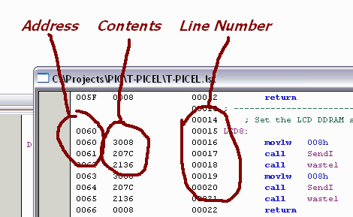  Toward the bottom of the file is a listing of all the symbols you have used and their values:  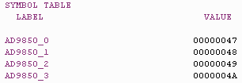  Still farther down is a map of your program memory use:  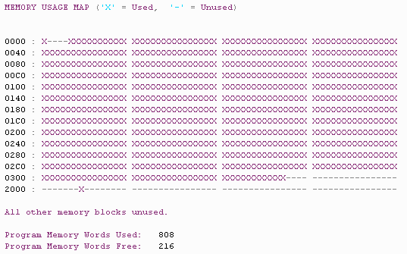
 | Continued on next page
The Listing File, Continued
What’s in the listing (continued) | Finally, there is a count of all the messages, including those you may have suppressed with the errorlevel directive:  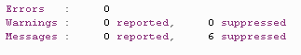
Page Titles | At the top of each page the listing shows the assembler (not MPLAB) version and assembly date, as well as the page number. The assembler can also be directed to include a title and subtitle to be shown at the top of each page.  This is controlled with the title and subtitle directives:  title “PIC-EL Test Suite”  subtitle “LCD Support Routines”
Additional listing control | The list directive can turn the listing on and off (useful for suppressing printing of uninteresting include files), as well as control various aspects of the listing. Perhaps the most useful is to control the tab size. MPLAB defaults to 4 character tabs, but the listing defaults to 8 character tabs. This is changed with the “b=” phrase in the list directive. Other useful features are the page length (n=) and the width (c=):  list b=4,c=132,n=60  Finally, there is a page directive that forces a new page. This can be useful to start a routine, or group of routines, at the top of the page:  page

Wrap Up
Introduction | In this lesson, we have looked at a number of assembler directives that allow us to control what the assembler processes and how to control the appearance of the listing file.
Coming Up | In the next lesson, we will install FPP, the program we will use to program the PIC with our software, and we will use FPP to test the programmer portion of our PIC-EL.

